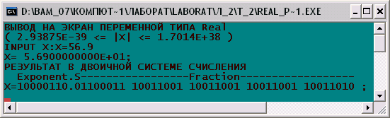
Addr+0
Addr+1
Addr+2
Addr+3
Addr+4
Addr+5
86 h
9A h
99 h
99 h
99 h
63 h

